PYTHON FUNCTIONS

What is a function?
A function is a block of code that performs a specific task.
Instead of writing the same code many times, we write it once inside a function and call it whenever needed.

Simple function without input:

def greet(): // Create the function named greet
print("Good morning") // print the message
greet() // calling the function

Function with input

def greet(name):
print("Hello", name)
greet("xxxx") // name is given as input to the function
greet("yyyy")

Function with return

def add(a, b):
return a + b
result = add(5, 3)
print(result)

return- gives the value back so we can store it, reuse it, or calculate with it.

Function with if condition

def check_even(num):
if num % 2 == 0:
return "Even"
else:
return "Odd"
print(check_even(4))
print(check_even(7))

Function with loop

def print_name(name):
for i in range(5):
print(name)
print_name("Ali")

Function with default value

def greet(name="Student"):
print("Hello", name)
greet("Ali")
greet()

If we do not give a name, Python uses the default value "Student".

Function with multiple inputs

def calculate_total(price, quantity):
total = price * quantity
return total
print(calculate_total(10, 5))

Function with multiple return values

def calculate(a, b):
add = a + b
subtract = a - b
multiply = a * b
return add, subtract, multiply
x, y, z = calculate(10, 5)
print(x)
print(y)
print(z)
Python returns the values as a tuple.

Function calling another function

def square(num):
return num * num
def display_square(value):
result = square(value)
print("Square is", result)
display_square(4)

display_square() calls the square() function inside it.

Inner function

An inner function means a function inside another function.
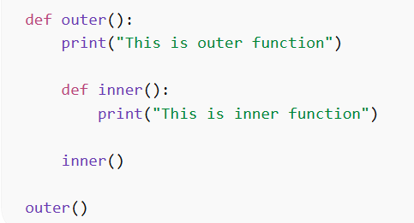

Function using *args
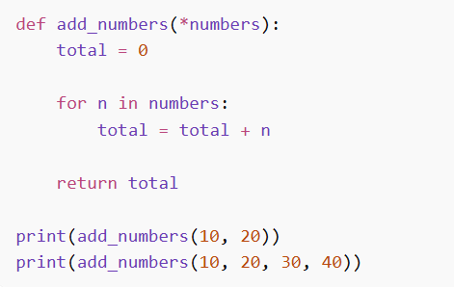

Assigning a New Name to a Function in Python
In Python, a function can have another name.
def greet():
print("Hello students")

say_hello = greet

greet()
say_hello()

Find the output for the following programs:

1.
def greet():
print("Hello")

greet()

Answer: -------------------------------

2.
def show():
print("A")
print("B")

show()
print("C")
Answer:

3.
def add(a, b):
print(a + b)
add(5, 3)

Answer: --------------------------------------

4.
def test():
return 10
print(test())
Answer: ---------------------------------

5.
def test():
print("Start")
return 5
print("End")

print(test())

Answer: -----------------------------------

6.
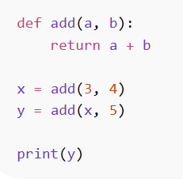

Answer: ---------------------------

7.
def welcome(name="Student"):
print("Welcome", name)
welcome("Ali")
welcome()

Answer:

8.

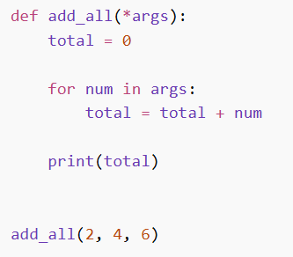
Answer:

9.

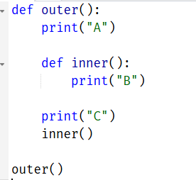

Answer:

10.

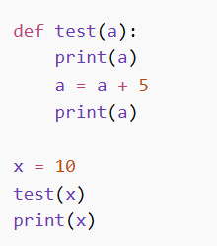

Answer:

11.

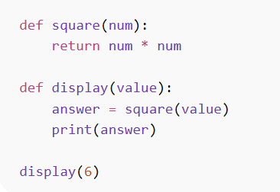
Answer:

Practice questions:
1.Write a function called greet() that prints:
Welcome to Python Lab

2. Write a function called mul(a, b) that accepts two numbers and prints their product.
3. Write a function called square(num) that returns the square of a number.
4. Write a function called check_even(num).
5. Write a function called print_numbers() that prints numbers from 1 to 5.

LAB 6: FUNCTION IN PYTHON

Instructions:
- You are to code the following programs in the lab and show the output to your lecturer.
- Write comment to make your programs readable.
- Use descriptive variables in your program (Name of the variables should show their purposes)
- Note: Design the solution using pseudocode before coding

Part A: Function

Function with variable
- Write a program that accepts a variable length of arguments and print the value. Hint: use function

Return multiple values from a function

- Write a program to create function calc() that will accept two variables and calculate the two variables. Hint: Use addition and subtraction.

Complete the given code below:

def calc(x, y):
# Write the missing Code
result = calc(40, 10)
print(result)

Function with a default argument

- Write a program to create a function named employee() using the following conditions:
- Program should accept the employee’s name and salary and display both.
- If the salary is missing in the function call, then assign default value 9000 to salary.
Inner function to calculate the addition

- Write a Python program to create the following:
  - Create an outer function that will accept two parameters, y and z.
  - Create an inner function inside an outer function that will calculate the addition of y and z.
  - Lastly, the outer function will add 5 into addition and return it

Assign a different name to function and call the function using the new name.

- Based on the example given, assign a new name to the function and call it using the new name.
def student(name, age):
print(name, age)
student("Kelvin", 26)

Maximum of Two Values:
- Write a function named max that accepts two integer values as arguments and returns the value that is the greater of the two. For example, if 7 and 12 are passed as arguments to the function, the function should return 12. Use the function in a program that prompts the user to enter two integer values. The program should display the value that is the greater of the two.

Built-in Function

- Generate a Python list of all the even numbers between 2 to 50.
- Find the largest number from the given list [4, 28, 97, 56, 16].

Part C : Homework
- You have decided to program a simple calculator. You calculator can perform the following operations:
  - It can multiply two numbers.
  - It can divide one number by another.
  - It can get the remainder of two numbers.
  - It can subtract one number from another.
Write a function that asks the user for two numbers, and the operation they wish to perform on these two numbers and return the result. Note: Choices should be entered as strings.
- Write a function that accepts a list of strings and sorts them alphabetically.

- Write a Python program to read name of student, TP Number and enter his/her all subject marks in list. Compute the total and percentage (Average) of a student. At the end display Name of student, TP Number, Total, Percentage and Grade of that semester by using function as defined below.

Score | Grade
80-100 | A+
75-79 | A
70-74 | B+
65-69 | B
60-64 | C+
55-59 | C
50-54 | C-
40-49 | D
0-39 | F

- Use Display function to print output.

- Use mark function to accept parameter and return total to Display function.

- Use average function by passing parameter which is generated in mark function.

- Use grade function by passing parameter which is generated in average function.

